**Ideation Phase**

**Define the Problem Statements**

|  |  |
| --- | --- |
| Date | 06 October 2022 |
| Team ID | PNT2022TMID09796 |
| Project Name | Classification of Arrhythmia by Using Deep  Learning with 2-D ECG Spectral Image  Representation |
| Maximum Marks | 2 Marks |

**Customer Problem Statement Template:**

Create a problem statement to understand your customer's point of view. The Customer Problem Statement template helps you focus on what matters to create experiences people will love.

A well-articulated customer problem statement allows you and your team to find the ideal solution for the challenges your customers face. Throughout the process, you’ll also be able to empathize with your customers, which helps you better understand how they perceive your product or service.

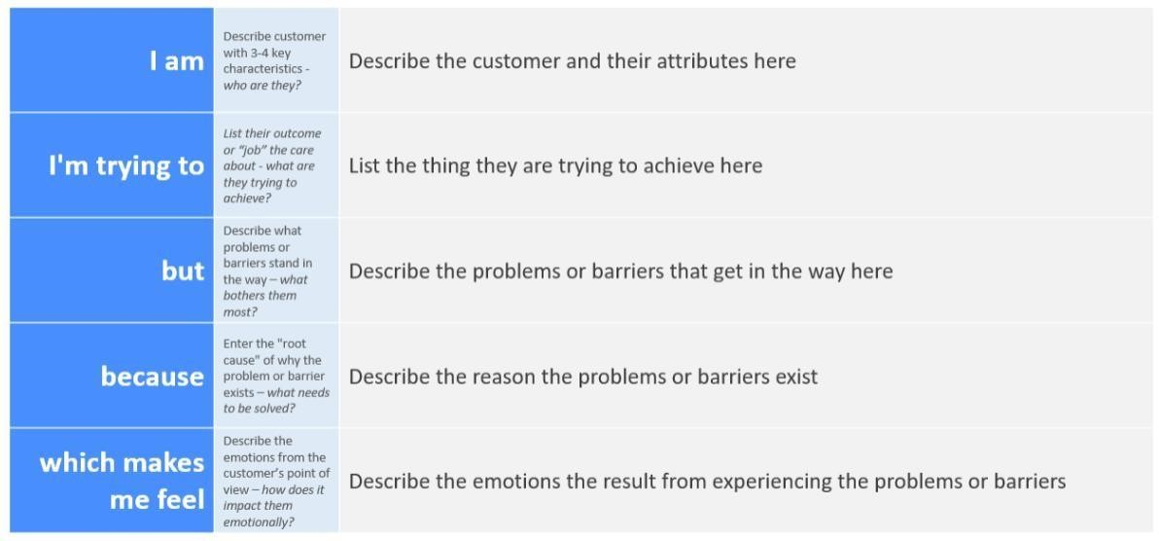

Reference: [https://miro.com/templates/customer-problem-statement/ **E**](https://miro.com/templates/customer-problem-statement/)**xample:**

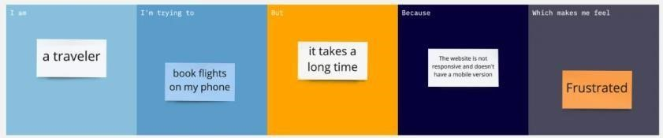

|  |  |  |  |  |  |
| --- | --- | --- | --- | --- | --- |
| **Problem**  **Statement (PS)** | **I am**  **(Customer)** | **I’m trying to** | **But** | **Because** | **Which makes me**  **feel** |
| PS-1 | Patient | Identify my  problem | Its is  difficult for me to reach out to consult a doctor | I’m regularly suffering from Angina | Dizziness |
| PS-2 | Patient | find the cause of my complication | I’m looking for an optimized way | I need to know the impact quicker | endure rapid heartbeat |
| PS-3 | Journalist | clarify my issue(rapid heartrate) | I can’t step out | I’m feeling fainting and dizziness | Nervous |